**block in Java** is a set of code enclosed within curly braces { } within any class, method, or [constructor](https://www.scientecheasy.com/2020/06/constructor-in-java.html/). It begins with an opening brace ( { ) and ends with an closing braces ( } ).

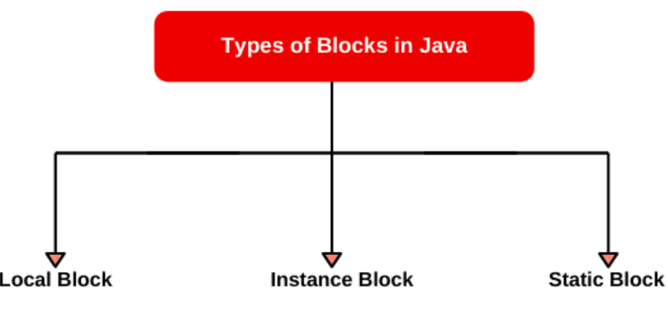

## Local Block in Java

A block defined inside a method, block, or constructor is called local block in Java.

1. **Instance Initializer block** is used to initialize the instance data member. It run each time when object of the class is created.
2. **Static block**